BlueSnap  
Integration Guide

(SFRA version)



**Table of Contents**

1 Summary 3

2 Component Owerview 4

2.1 Functional Overview 4

2.2 Limitations, Constraints 4

2.3 Compatibility 4

2.4 Privacy, Payment 4

3 Implementation Guide 5

3.1 General Implementation 5

3.1.1 Installing the Cartridge on the sandbox 5

3.1.2 Set Up Business Manager 7

3.2 Configuring preferences 13

3.2.1 Configuring the cartridge via BM extension 13

3.2.2 How to modify payment method name 14

3.2.3 How to set SoftDescriptor for customer 16

3.2.4 How to use Bluesnap Reports 17

3.3 Integrating BlueSnap into your storefront 18

3.3.1 Perform changes in templates 18

3.3.2 Perform changes in client’s javascript 25

4 Operations, Maintenance 30

4.1 Data Storage 30

4.2 Availability 30

4.3 Support 31

5 User Guide 31

5.1 Roles, Responsibilities 31

5.2 Business Manager 31

5.3 Storefront Functionality 31

6 Known Issues 31

7 Release History 31

# Summary

This document provides technical instructions for using the BlueSnap SFCC Cartridge to integrate the BlueSnap payment methods into a SFCC storefront.

**Glossary**

|  |  |
| --- | --- |
| **Term** | **Description** |
| SFCC | SalesForce Commerce Cloud |
| Business Manager (BM) | The primary tool used to configure the SFCC platform and customer storefront |
| SFRA | StoreFront Reference Architecture |

# Component Owerview

## Functional Overview

The BlueSnap cartridge enables customers to select the BlueSnap payment methods on checkout and pay for order with the BlueSnap all-in-One Payment Platform. In case the service BlueSnap is down, the storefront continues to work without the service. All errors work of the service are saved in the log file.

## Limitations, Constraints

Use of the BlueSnap cartridge requires credentials and keys from the BlueSnap. Please register on bluesnap.com and contact BlueSnap customer service.

## Compatibility

The cartridge is designed for Salesforce Commerce Cloud API version 19.10 (Compatibility Mode: 19.10) with SFRA version 4.4.1.

## Privacy, Payment

The BlueSnap cartridge can collect and process user profile information or billing information. For additional privacy information, please contact your BlueSnap Manager.

# Implementation Guide

## General Implementation

### Installing the Cartridge on the sandbox

1. Open UX Studio.  
2. Import downloaded cartridge. Select on the Import screen:

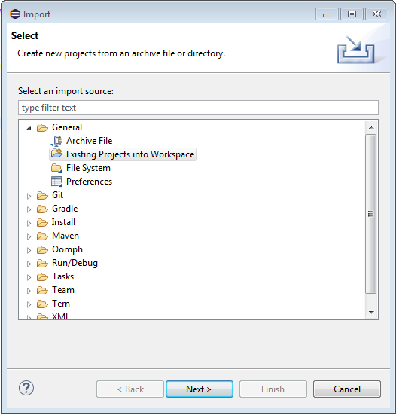

3. Link the cartridges to the sandbox.

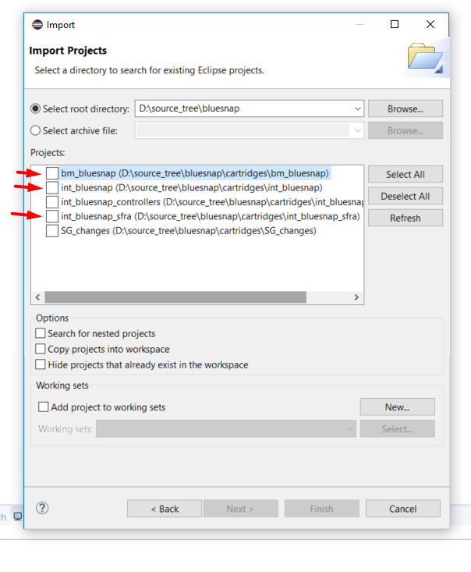

4. Select sandbox connection then Properties. Select Project Reference and check in. 

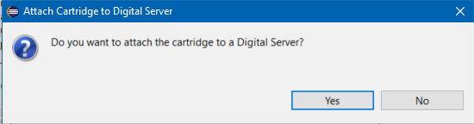

### Set Up Business Manager

1. Go to **Business Manager -> Site -> Manage Sites**. Select the correct site then select **Settings** tab. In the cartridge path add “int_bluesnap” and “int_bluesnap_controllers” cartridges:

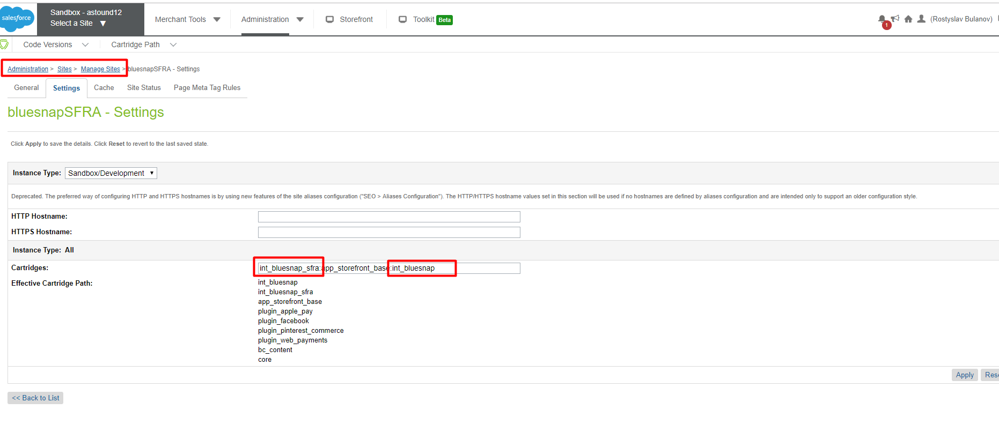

2. Go to **Administration -> Site Development ->Site Import & Export** and upload bluesnap.zip from meta folder

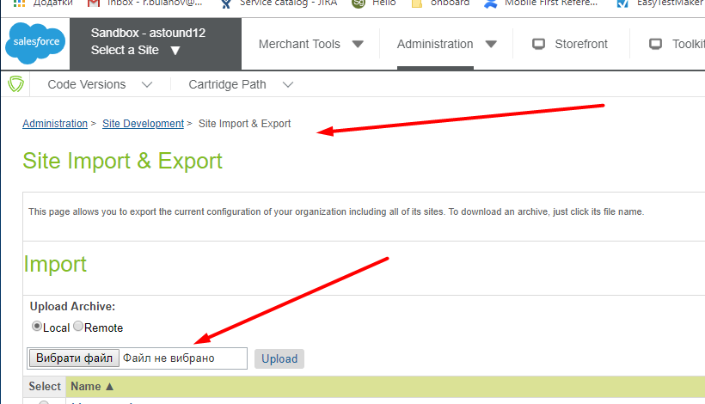

3. Import bluesnap.zip.zip:

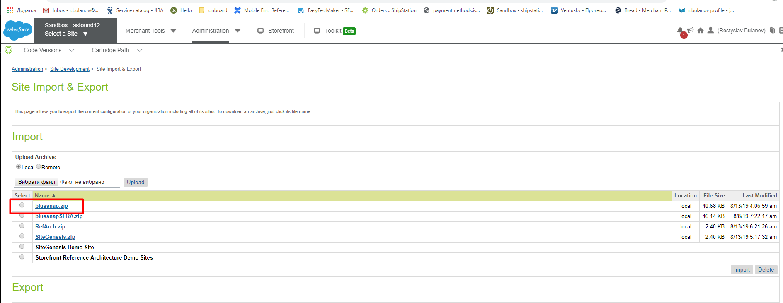

4. Configure Service credentials: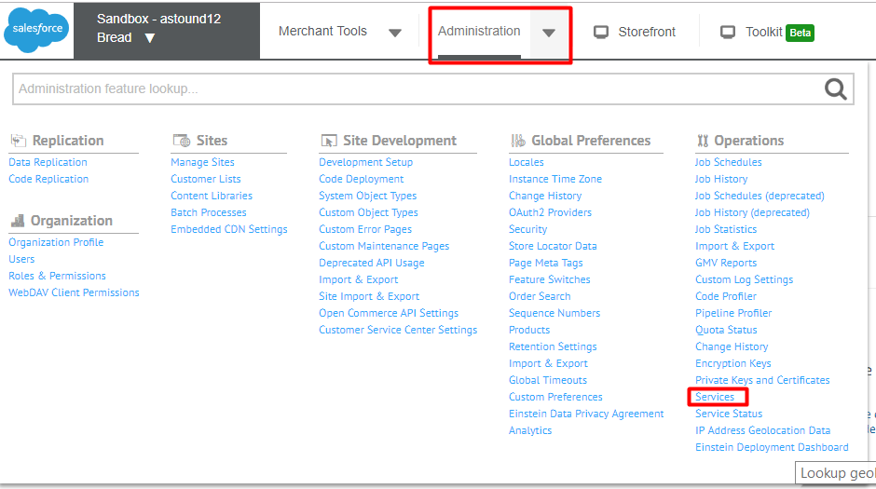

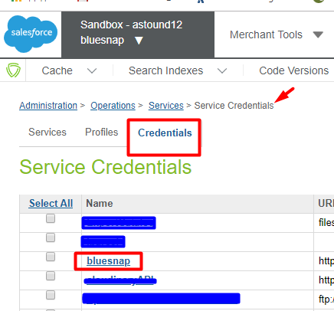

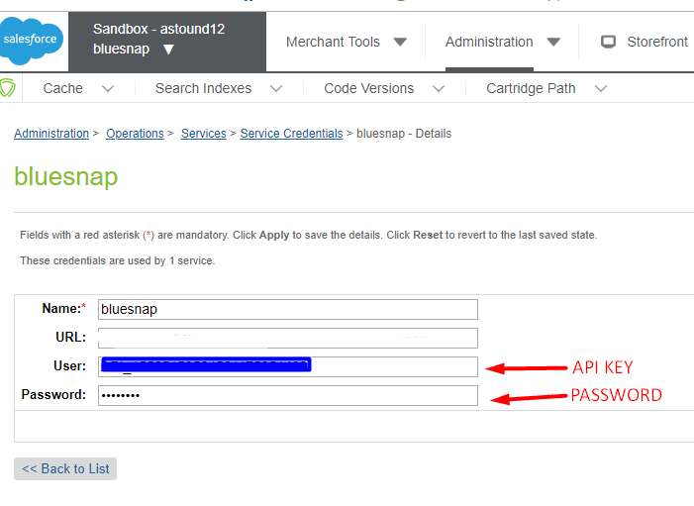

5. Add **bm_bluesnap** cartridge to the BM cartridge path.

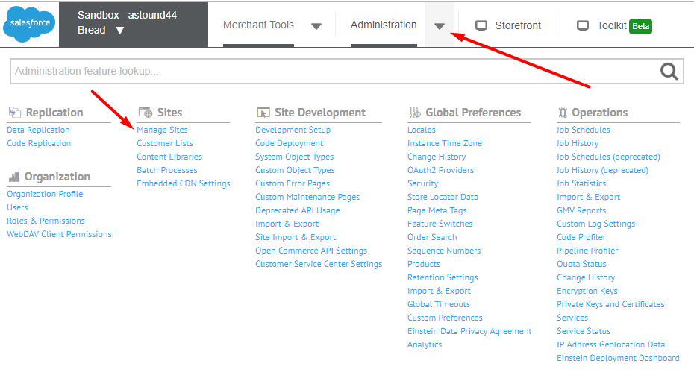

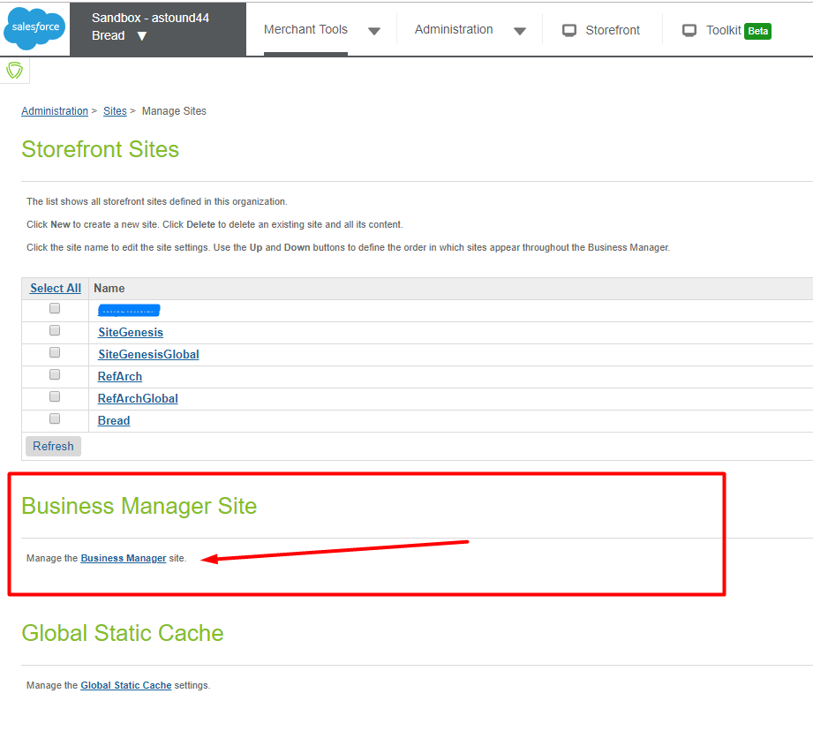

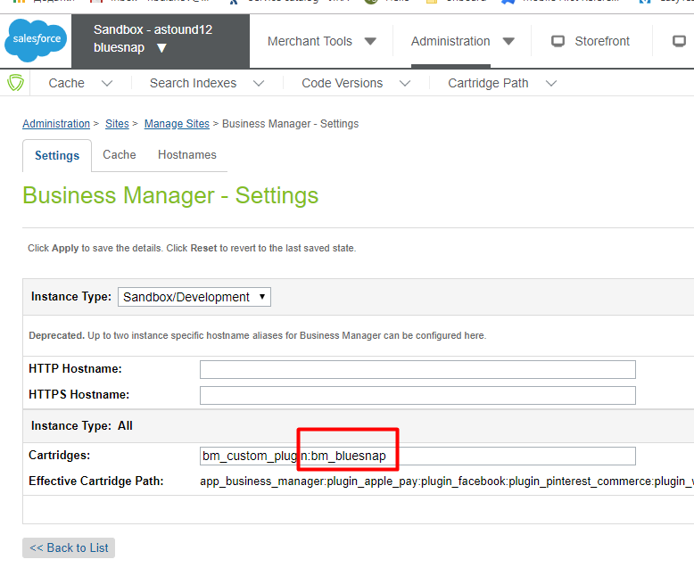

6. Add permission for merchant to use BlueSnap BM extension. Go to

Administration > Organization > Roles > {Merchant Role} - Business Manager Modules and select proper context

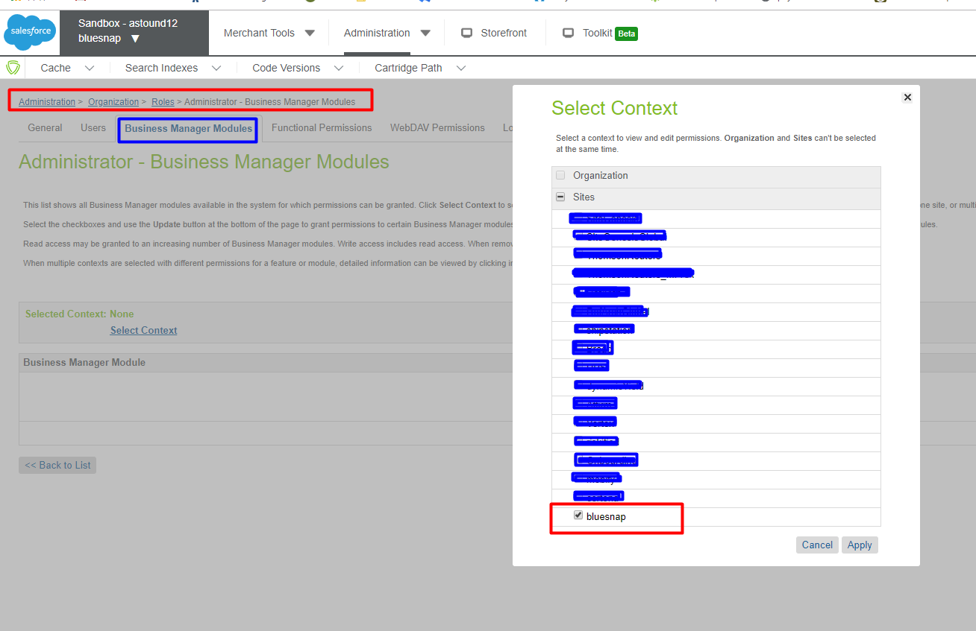

7. Select the checkboxes and use the Update button at the bottom of the page to grant permissions to BlueSnap Settings and BlueSnap Reports Business Manager modules

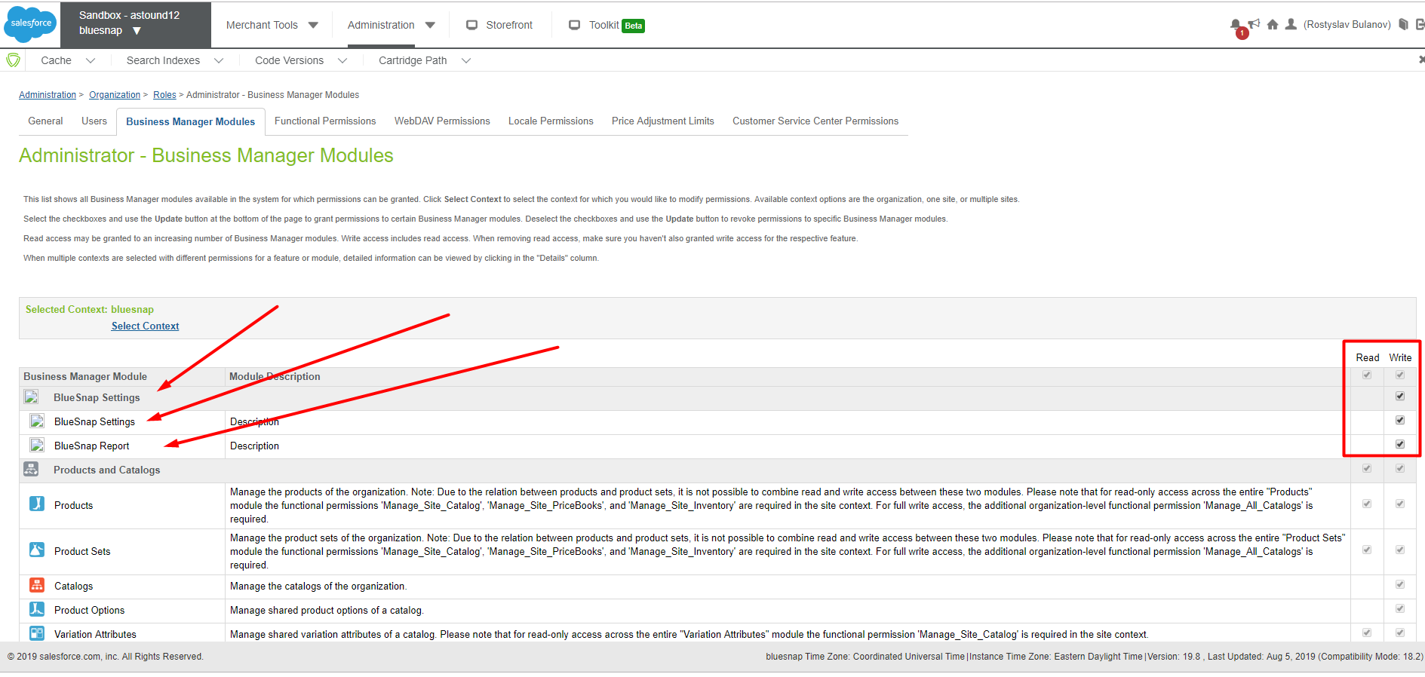

8. Reload page. BlueSnap section should appear in Merchant Tools

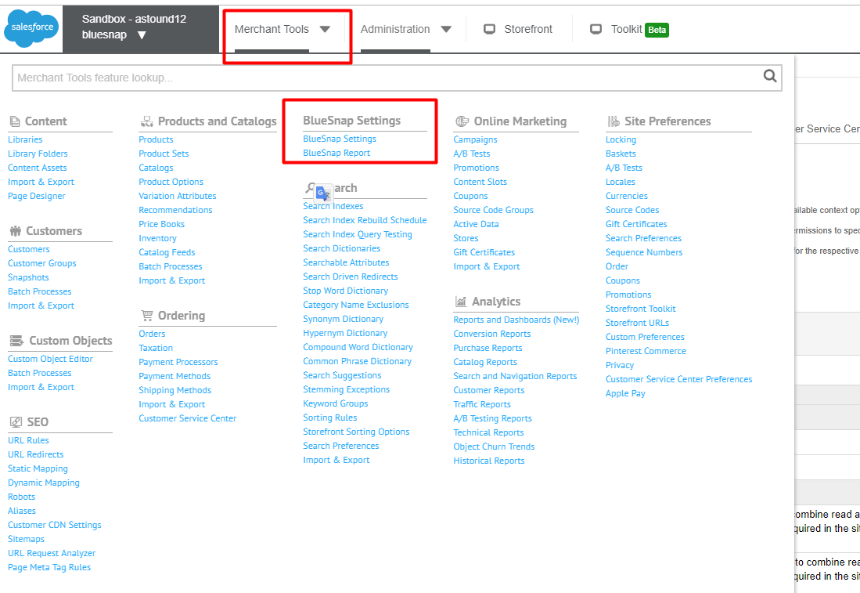

## Configuring preferences

### Configuring the cartridge via BM extension

1. Go to Business Manager: **Sites -> Your Site ->Merchant tools -> BlueSnap Settings**

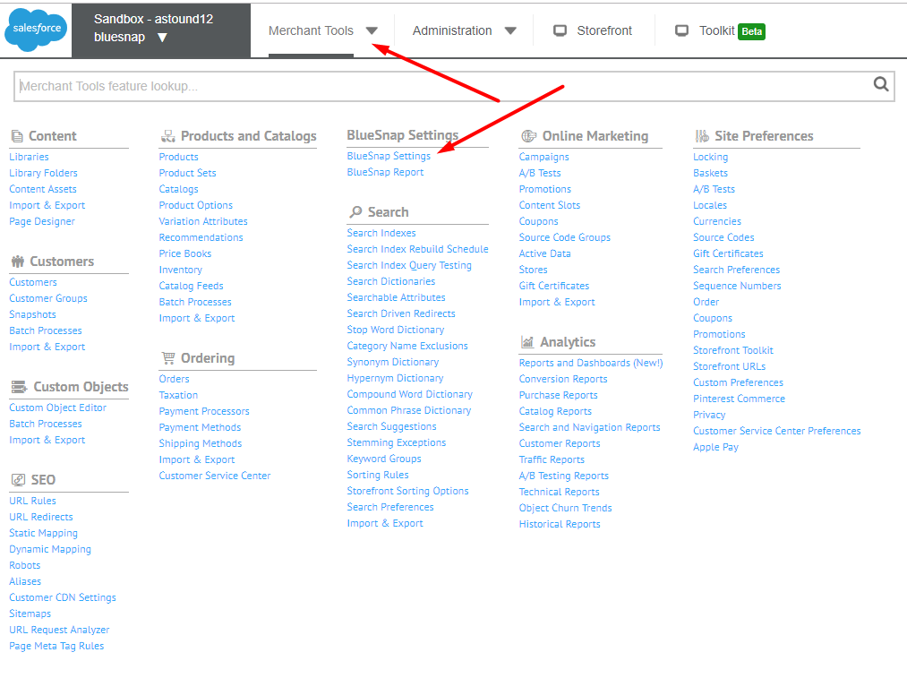

2. Below is an example of how to complete the fields in the blueSnap settings area:

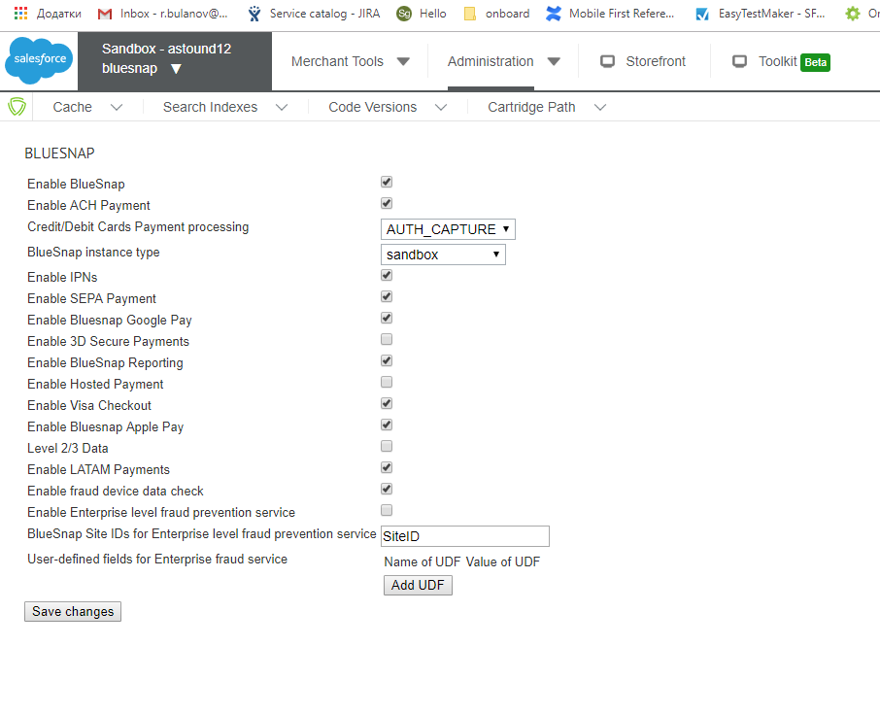

**Descriptions:**

* Enable BlueSnap — enables cartridge
* Enable ACH Payment
* Credit/Debit Cards Payment processing — AUTH_CAPTURE/ AUTH_ONLY
* BlueSnap instance type SANDBOX/PRODUCTION
* Enable IPNs — enables handling of Instant Payment Notifications
* Enable SEPA Payment
* Enable Bluesnap Google Pay
* Enable 3D Secure Payments
* Enable BlueSnap Reporting
* Enable Hosted Payment
* Enable Visa Checkout
* Enable Bluesnap Apple Pay
* Level 2/3 Data — Turns on level 3 data in the request
* Enable LATAM Payments
* Enable fraud device data check
* Enable Enterprise level fraud prevention service
* BlueSnap Site IDs for Enterprise level fraud prevention service
* User-defined fields for Enterprise fraud service

### **How to modify payment method name**

1. Go to Merchant Tools > Ordering > Payment Methods
2. Find payment method with **NEEDED** id.
3. Click on it in the **Name** column.
4. Change the name and press **Apply** button.

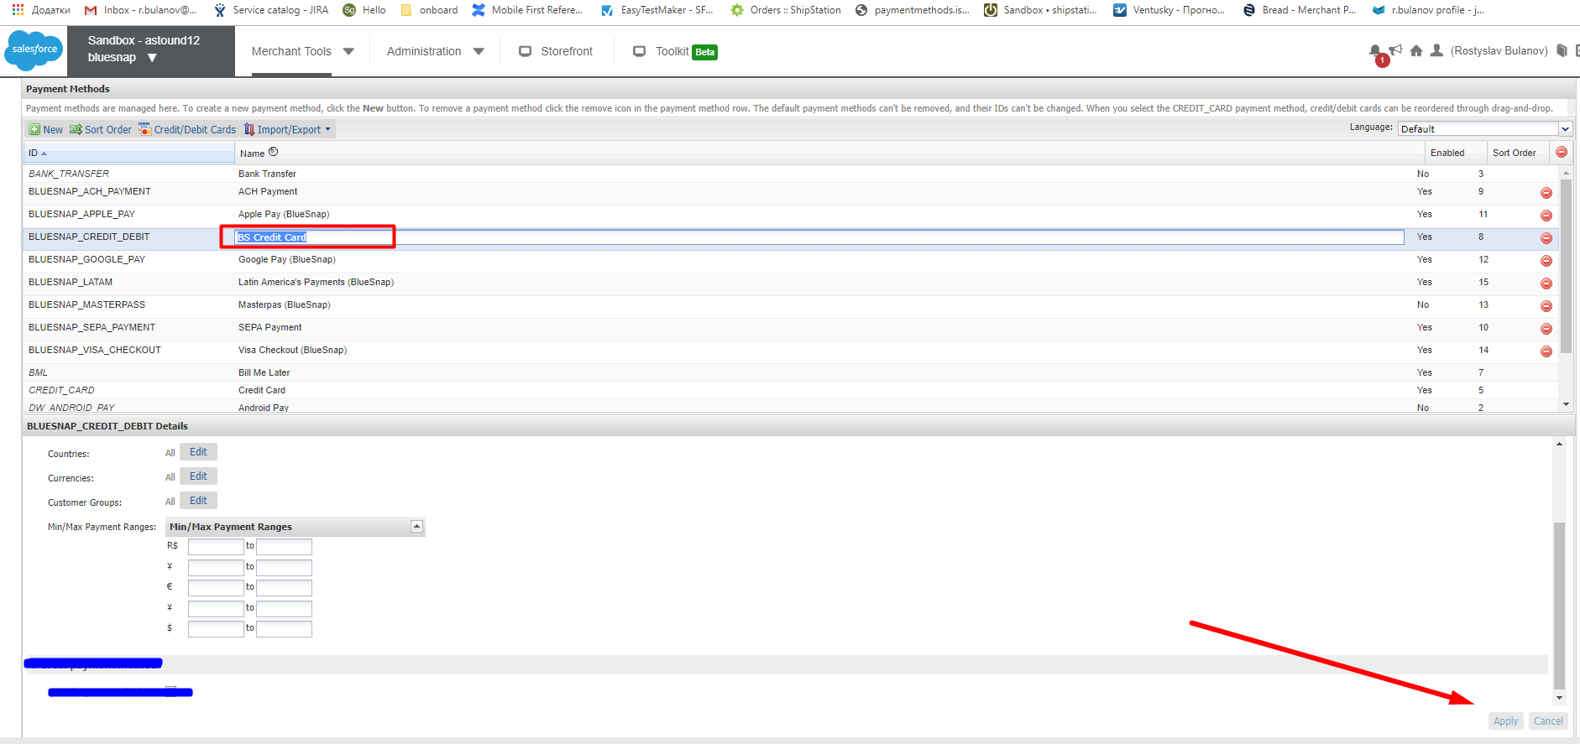

### How to set SoftDescriptor for customer

1. Go to Merchant Tools -> Customers

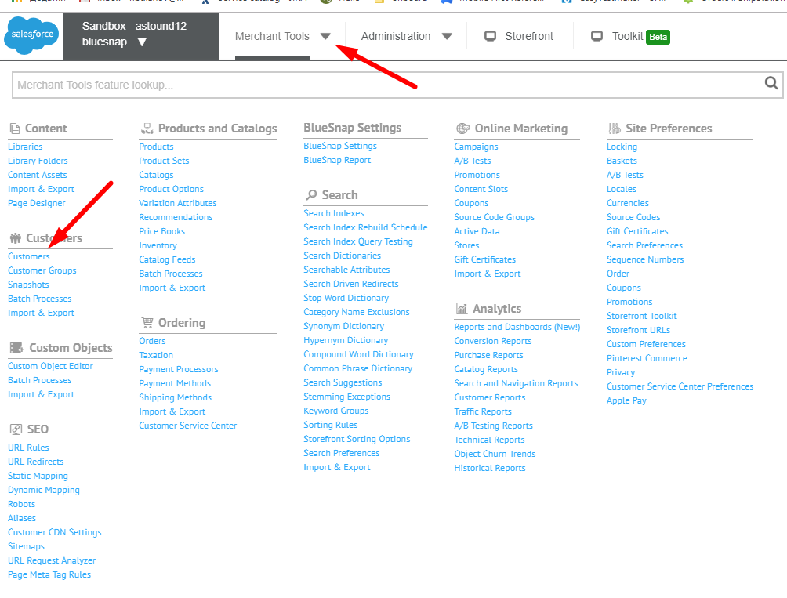

2. Select user

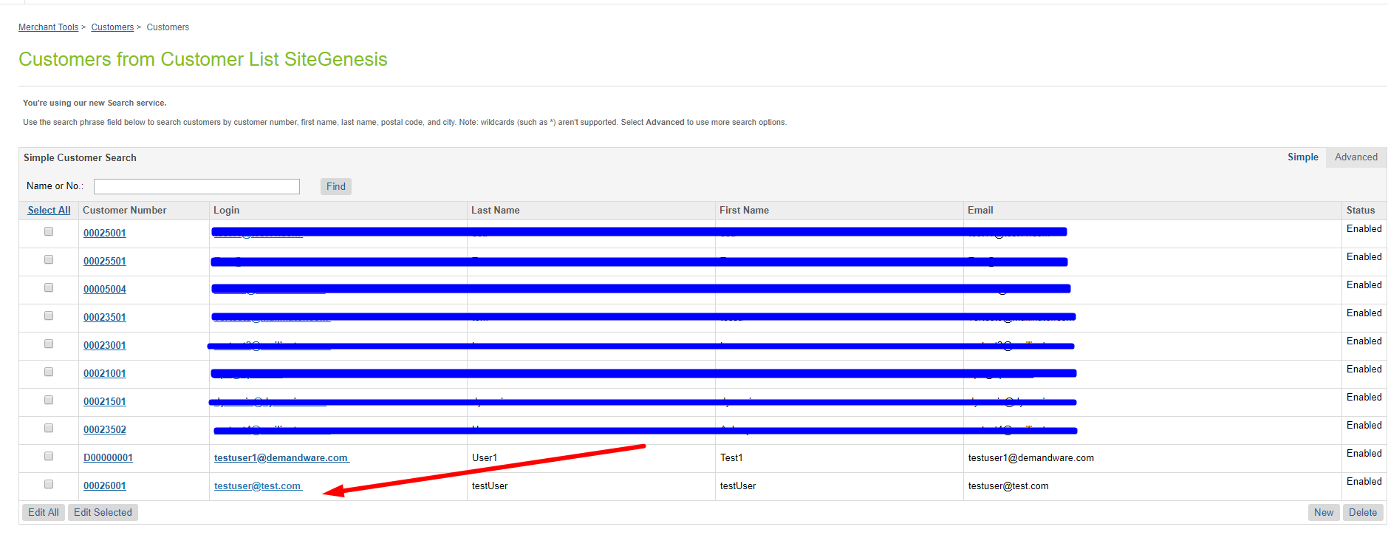

3. Find BlueSnap section fill the SoftDescriptor field and press Apply

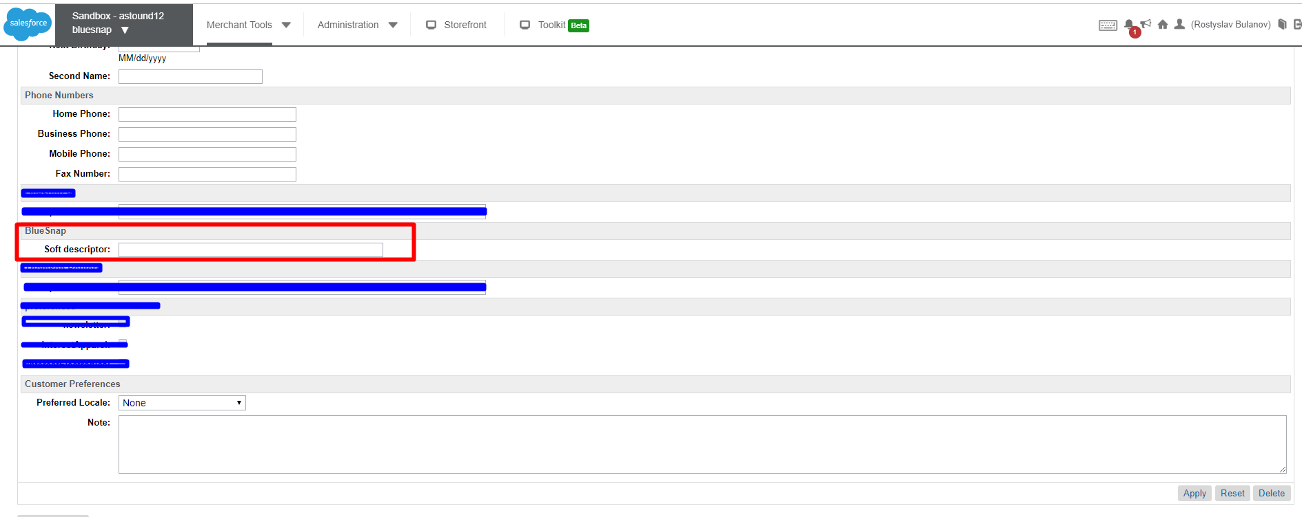

### How to use Bluesnap Reports

1. Go to Merchant Tools -> Bluesnap Settings -> BlueSnap Report

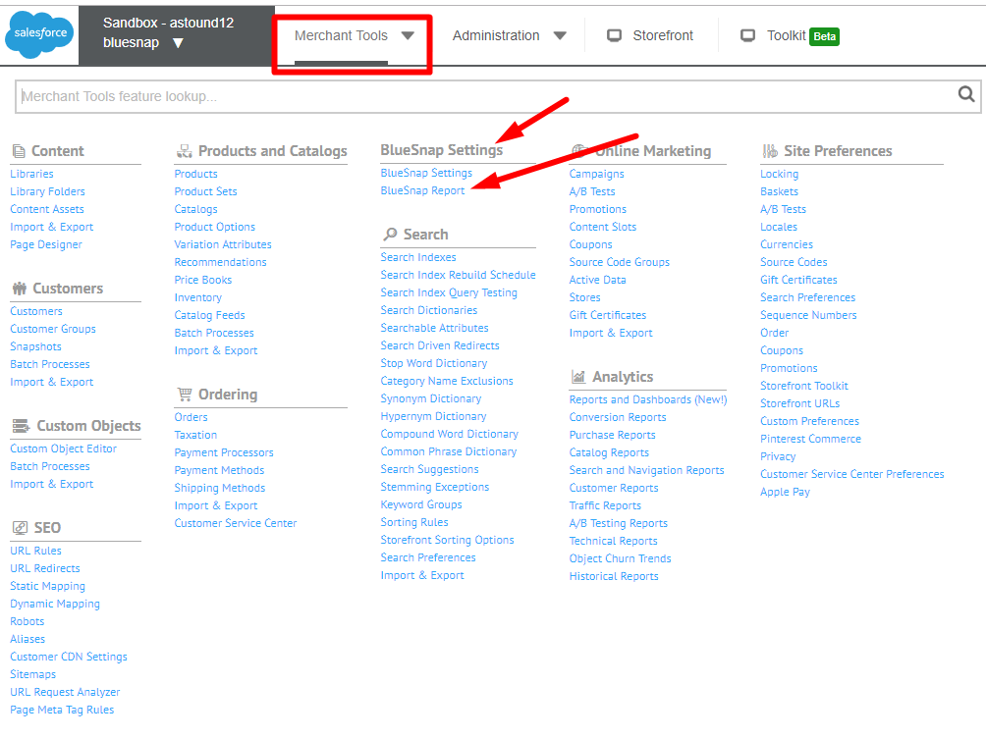

1. Choose Report type fill the form and press Submit

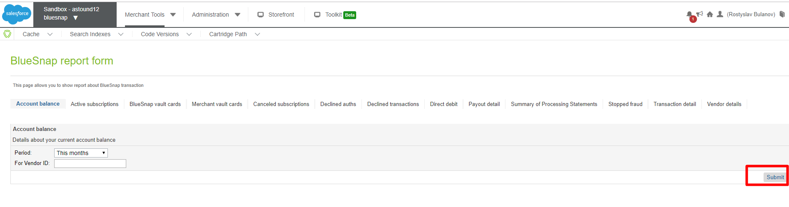

## Integrating BlueSnap into your storefront

### Perform changes in templates

***Note: all changes are already made in int_bluesnap_sfra cartridge.***

1. ***app_storefront_base/cartridge/templates/default/account/dashboardProfileCards.isml***

Put the following raws in line 22

|  |
| --- |
| <!---Bluesnap Vaule--->  <isinclude template="account/bluesnapVaultCard"/> |

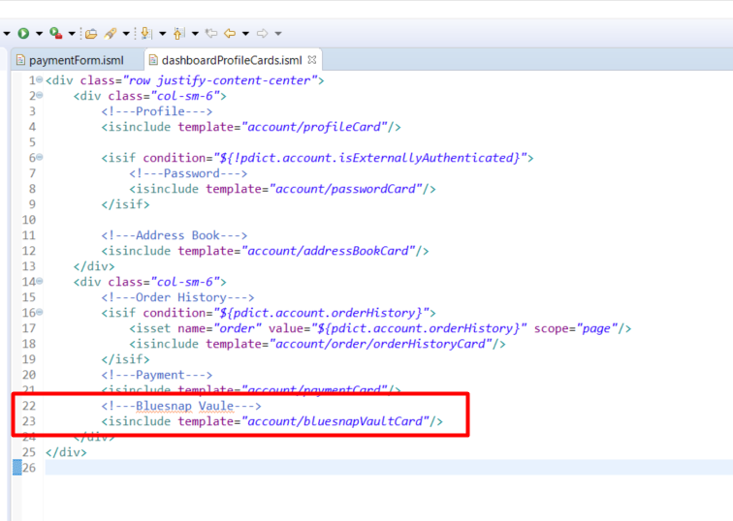

1. ***app_storefront_base/cartridge/templates/default/account/payment/paymentForm.isml***

Paste following code sample into 100 line:

|  |
| --- |
| <div class="make-default-payment">  <div class="form-group custom-control custom-checkbox">  <input type="checkbox" class="custom-control-input" id="saveToBluesnapVault"  <isprint value="${pdict.paymentForm.saveToBluesnapVault.attributes}" encoding="htmlsinglequote" />  >  <label class="custom-control-label" for="saveToBluesnapVault">  Add to BlueSnap Vault for one-click checkout  </label>  </div>  </div> |

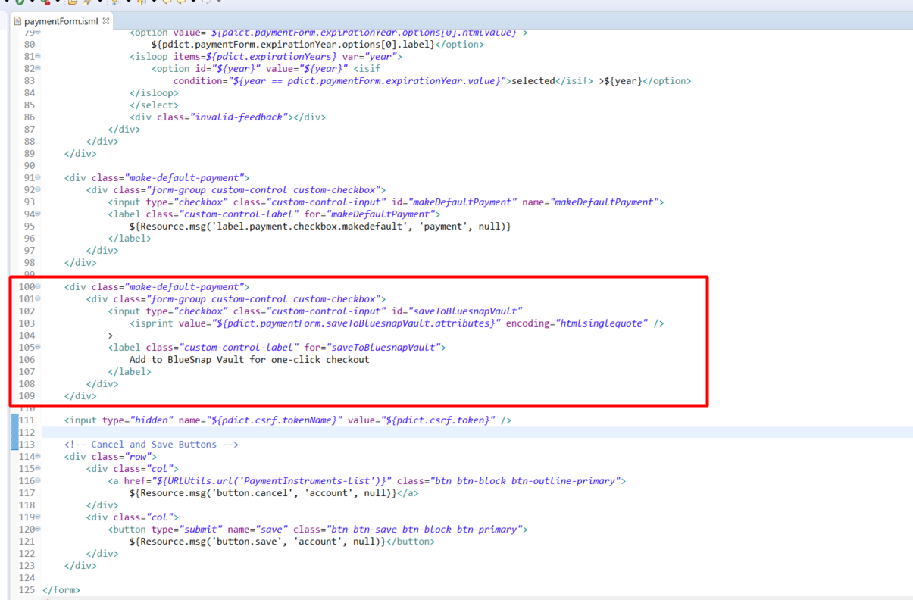

1. ***app_storefront_base/cartridge/templates/default/checkout/checkout.isml***

Paste the following line into the 2 line

|  |
| --- |
| <isinclude template="frauddatacollect" /> |

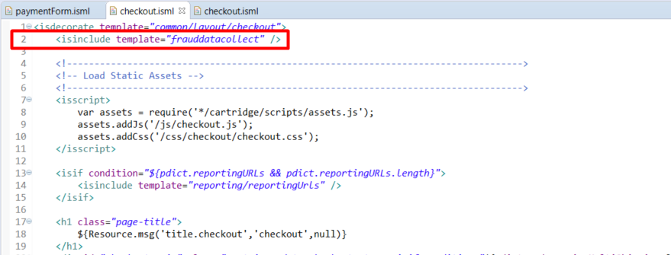

Paste the following lines into the 72 line

|  |
| --- |
| <div id="bluesnap-payment-buttons" data-url='${dw.web.URLUtils.https("PaymentCalls-LoaderPayment")}'>  <iscomment>  <!-- Google Pay button -->  <isinclude template="bluesnap/googlepay" />  <!-- Visa Checkout button -->  <isinclude template="bluesnap/visacheckout" />  </iscomment>  </div> |

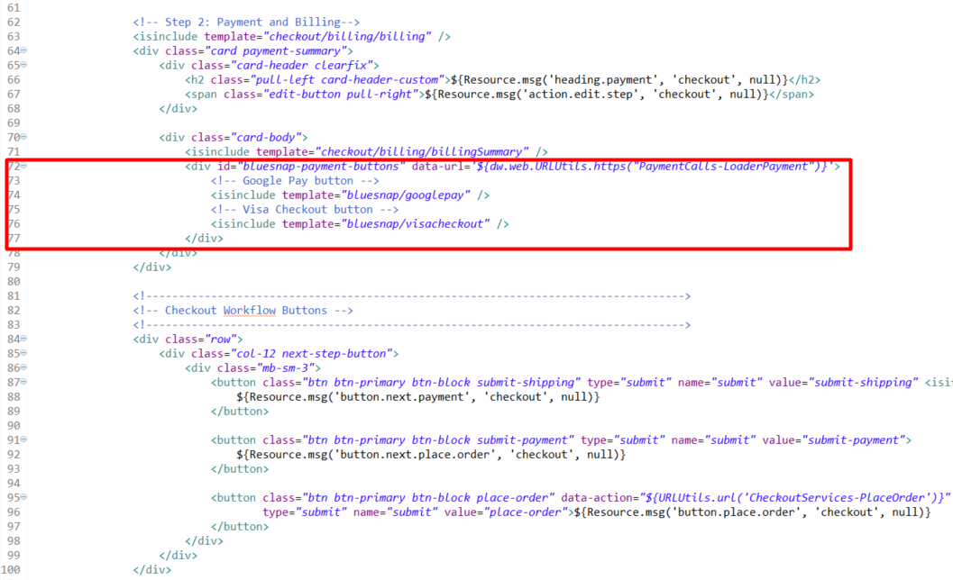

1. ***app_storefront_base/cartridge/templates/default/checkout/billing/paymentOptions/  
   creditCardContent.isml***

**Replace** first div with following

|  |
| --- |
| <div class="tab-pane credit-card-content  ${activePaymentMethods === paymentOption.ID ? 'active' : ''}"  id="credit-card-content" role="tabpanel"> |

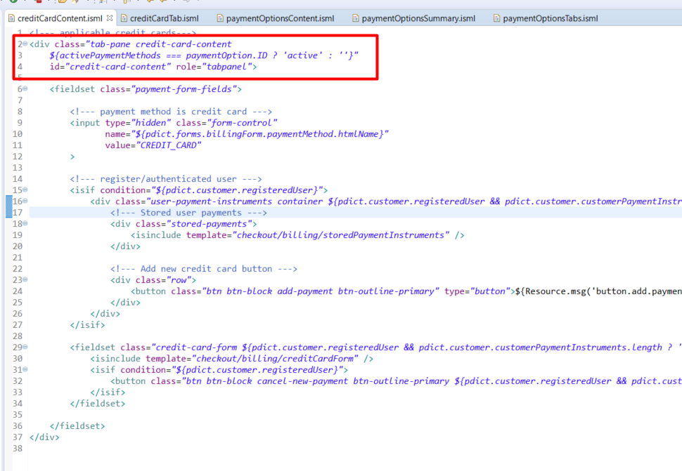

1. ***app_storefront_base/cartridge/templates/default/checkout/billing/paymentOptions/  
   creditCardTab.isml***

**Replace** <a> tag attributes into the 2 line with following:

|  |
| --- |
| <a class="nav-link credit-card-tab  ${activePaymentMethods === paymentOption.ID ? 'active' : ''}"  data-toggle="tab" href="#credit-card-content" role="tab"> |

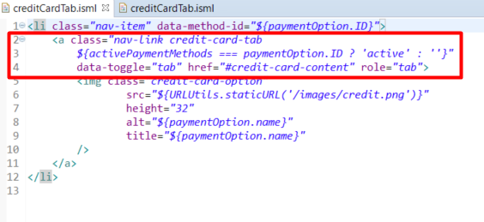

1. ***app_storefront_base/cartridge/templates/default/checkout/billing/paymentOptions/  
   paymentOptionsContent.isml***

Insert following code inside of <loop>:

|  |
| --- |
| <isif condition="${paymentOption.ID === 'BLUESNAP_CREDIT_DEBIT' && getBlueSnapPreference('Enable')}">  <isinclude template="checkout/billing/paymentOptions/bluesnapcreditcardContent" />  </isif>  <isif condition="${paymentOption.ID === 'BLUESNAP_ACH_PAYMENT' && getBlueSnapPreference('Enable') && getBlueSnapPreference('ACH')}">  <isinclude template="checkout/billing/paymentOptions/bluesnapAchContent" />  </isif>  <isif condition="${paymentOption.ID === 'BLUESNAP_SEPA_PAYMENT' && getBlueSnapPreference('Enable') && getBlueSnapPreference('SEPA')}">  <isinclude template="checkout/billing/paymentOptions/bluesnapSepaContent" />  </isif>  <isif condition="${paymentOption.ID === 'BLUESNAP_GOOGLE_PAY' && getBlueSnapPreference('Enable') && getBlueSnapPreference('GooglePay')}">  <isinclude template="checkout/billing/paymentOptions/bluesnapGooglePayContent" />  </isif>  <isif condition="${paymentOption.ID === 'BLUESNAP_VISA_CHECKOUT' && getBlueSnapPreference('Enable') && getBlueSnapPreference('VisaCheckout')}">  <isinclude template="checkout/billing/paymentOptions/bluesnapVisaCheckoutContent" />  </isif>  <isif condition="${paymentOption.ID === 'BLUESNAP_APPLE_PAY' && getBlueSnapPreference('Enable') && getBlueSnapPreference('ApplePay')}">  <isinclude template="checkout/billing/paymentOptions/bluesnapApplePayContent" />  </isif>  <isif condition="${paymentOption.ID === 'BLUESNAP_LATAM' && getBlueSnapPreference('Enable') && getBlueSnapPreference('LATAM')}">  <isinclude template="checkout/billing/paymentOptions/bluesnapLatamContent" />  </isif> |

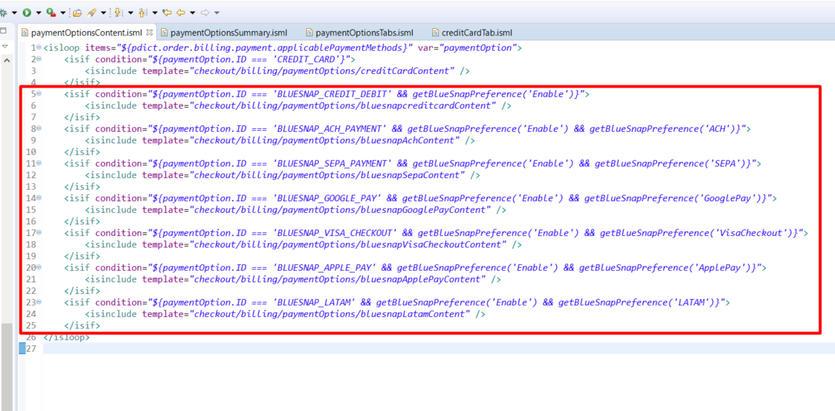

1. ***app_storefront_base/cartridge/templates/default/checkout/billing/paymentOptions/  
   paymentOptionsSummary.isml***

Insert following code inside of <loop>:

|  |
| --- |
| <isif condition="${payment.paymentMethod === 'BLUESNAP_CREDIT_DEBIT' || payment.paymentMethod === 'BLUESNAP_LATAM'}">  <isinclude template="checkout/billing/paymentOptions/bluesnapcreditcardSummary" />  </isif>  <isif condition="${payment.paymentMethod === 'BLUESNAP_ACH_PAYMENT'}">  <isinclude template="checkout/billing/paymentOptions/bluesnapAchSummary" />  </isif>  <isif condition="${payment.paymentMethod === 'BLUESNAP_SEPA_PAYMENT'}">  <isinclude template="checkout/billing/paymentOptions/bluesnapSepaSummary" />  </isif>  <isif condition="${payment.paymentMethod === 'BLUESNAP_GOOGLE_PAY'}">  <div class="credit-card-type">  <span>${Resource.msg('msg.payment.googlepay', 'bluesnap', null)}</span>  </div>  </isif>  <isif condition="${payment.paymentMethod === 'BLUESNAP_APPLE_PAY'}">  <div class="credit-card-type">  <span>${Resource.msg('msg.payment.applepay', 'bluesnap', null)}</span>  </div>  </isif>  <isif condition="${payment.paymentMethod === 'BLUESNAP_VISA_CHECKOUT'}">  <div class="credit-card-type">  <span>${Resource.msg('msg.payment.visacheckout', 'bluesnap', null)}</span>  </div>  </isif> |

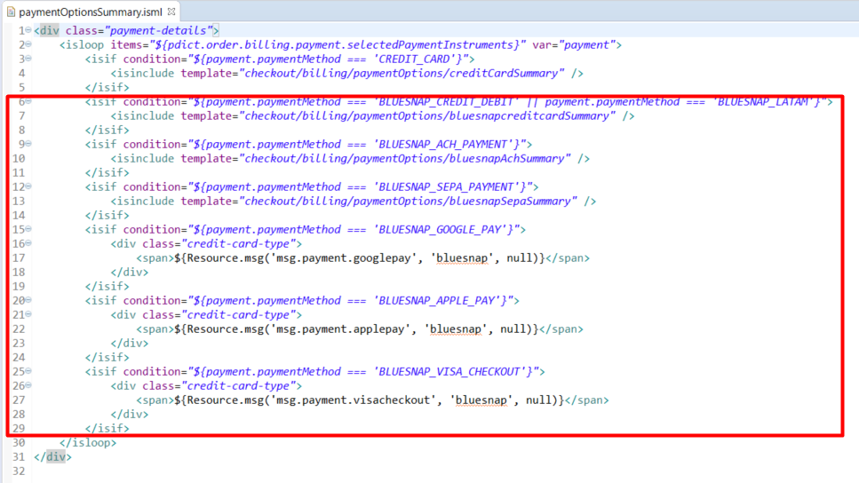

1. ***app_storefront_base/cartridge/templates/default/checkout/billing/paymentOptions/paymentOptionsTabs.isml***

Insert following code inside of <loop>:

|  |
| --- |
| <isif condition="${paymentOption.ID === 'BLUESNAP_CREDIT_DEBIT' && getBlueSnapPreference('Enable')}">  <isinclude template="checkout/billing/paymentOptions/bluesnapcreditcardTab" />  </isif>  <isif condition="${paymentOption.ID === 'BLUESNAP_ACH_PAYMENT' && getBlueSnapPreference('Enable') && getBlueSnapPreference('ACH')}">  <isinclude template="checkout/billing/paymentOptions/bluesnapAchTab" />  </isif>  <isif condition="${paymentOption.ID === 'BLUESNAP_SEPA_PAYMENT' && getBlueSnapPreference('Enable') && getBlueSnapPreference('SEPA')}">  <isinclude template="checkout/billing/paymentOptions/bluesnapSepaTab" />  </isif>  <isif condition="${paymentOption.ID === 'BLUESNAP_GOOGLE_PAY' && getBlueSnapPreference('Enable') && getBlueSnapPreference('GooglePay')}">  <isinclude template="checkout/billing/paymentOptions/bluesnapGooglePayTab" />  </isif>  <isif condition="${paymentOption.ID === 'BLUESNAP_VISA_CHECKOUT' && getBlueSnapPreference('Enable') && getBlueSnapPreference('VisaCheckout')}">  <isinclude template="checkout/billing/paymentOptions/bluesnapVisaCheckoutTab" />  </isif>  <isif condition="${paymentOption.ID === 'BLUESNAP_APPLE_PAY' && getBlueSnapPreference('Enable') && getBlueSnapPreference('ApplePay')}">  <isinclude template="checkout/billing/paymentOptions/bluesnapApplePayTab" />  </isif>  <isif condition="${paymentOption.ID === 'BLUESNAP_LATAM' && getBlueSnapPreference('Enable') && getBlueSnapPreference('LATAM')}">  <isinclude template="checkout/billing/paymentOptions/bluesnapLatamTab" />  </isif> |

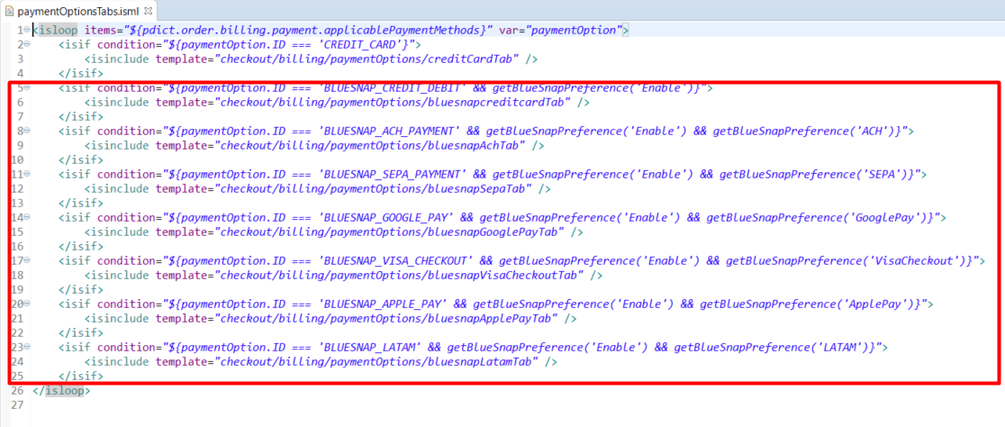

1. ***int_bluesnap_sfra/cartridge/templates/default/checkout/billing/paymentOptions.isml***

Replace <isif> condition inside of <isloop> operator

|  |
| --- |
| <isif condition="${paymentOption.ID === 'CREDIT_CARD'  || (paymentOption.ID === 'BLUESNAP_CREDIT_DEBIT' && getBlueSnapPreference('Enable'))  || (paymentOption.ID === 'BLUESNAP_ACH_PAYMENT' && getBlueSnapPreference('Enable') && getBlueSnapPreference('ACH'))  || (paymentOption.ID === 'BLUESNAP_SEPA_PAYMENT' && getBlueSnapPreference('Enable') && getBlueSnapPreference('SEPA'))  || (paymentOption.ID === 'BLUESNAP_GOOGLE_PAY' && getBlueSnapPreference('Enable') && getBlueSnapPreference('GooglePay'))  || (paymentOption.ID === 'BLUESNAP_VISA_CHECKOUT' && getBlueSnapPreference('Enable') && getBlueSnapPreference('VisaCheckout'))  || (paymentOption.ID === 'BLUESNAP_APPLE_PAY' && getBlueSnapPreference('Enable') && getBlueSnapPreference('ApplePay'))  || (paymentOption.ID === 'BLUESNAP_LATAM' && getBlueSnapPreference('Enable') && getBlueSnapPreference('LATAM'))  }" >  <isset name="activePaymentMethods" value="${paymentOption.ID}" scope="page"/>  <isbreak/>  </isif> |

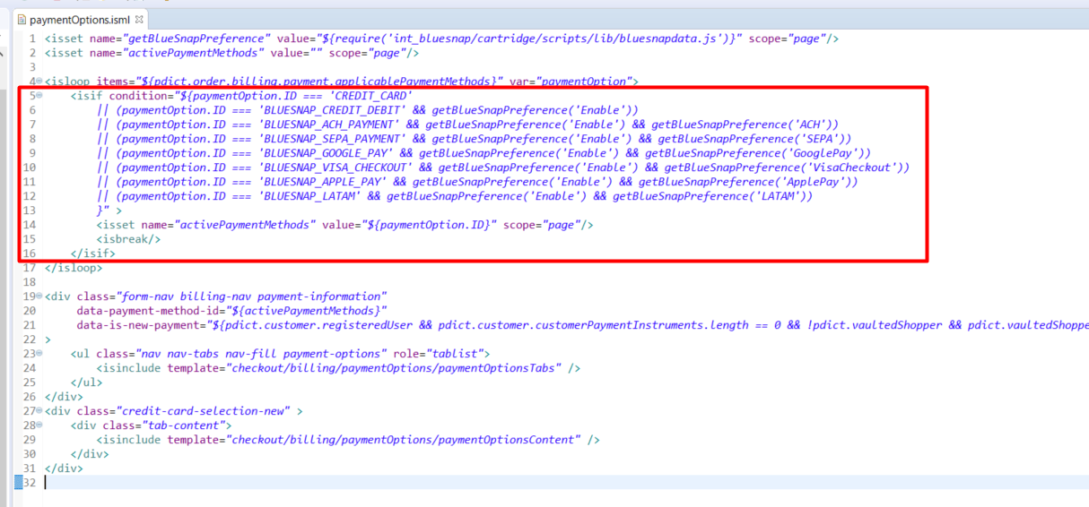

### Perform changes in client’s javascript

**Note:** In case you need to build client’s javascript in your own way: all client javascript files are located in static folders of **int_bluesnap** and **int_bluesnap_controllers** cartridges.

1. **int_bluesnap_sfra/cartridge/client/default/checkout/billing.js**

Replace lines 161-169 with following

|  |
| --- |
| switch (order.billing.payment.selectedPaymentInstruments[0].paymentMethod) {  case 'BLUESNAP_ACH_PAYMENT':  htmlToAppend += '<span>' + order.resources.bluesnap.achPaymentMethod + '</span>'  + '<div><span>' + order.resources.bluesnap.bankAccountNumber + ' '  + order.billing.payment.selectedPaymentInstruments[0].bankAccountNumberLastDigits  + '</span></div>'  + '<div><span>' + order.resources.bluesnap.routingnumber + ' '  + order.billing.payment.selectedPaymentInstruments[0].bankRoutingNumber  + '</span></div>';  break;  case 'BLUESNAP_SEPA_PAYMENT':  htmlToAppend += '<span>' + order.resources.bluesnap.sepaPaymentMethod + '</span>'  + '<div><span>' + order.resources.bluesnap.iban + ' '  + order.billing.payment.selectedPaymentInstruments[0].iban  + '</span></div>';  break;  case 'BLUESNAP_GOOGLE_PAY':  htmlToAppend += order.resources.bluesnap.googlePay;  $('.btn.place-order').attr('disabled', true);  break;  case 'BLUESNAP_APPLE_PAY':  htmlToAppend += order.resources.bluesnap.applePay;  $('.btn.place-order').attr('disabled', true);  break;  case 'BLUESNAP_VISA_CHECKOUT':  htmlToAppend += order.resources.bluesnap.visacheCkout;  $('.btn.place-order').attr('disabled', true);  break;  default:  htmlToAppend += '<span>' + order.resources.cardType + ' '  + order.billing.payment.selectedPaymentInstruments[0].type  + '</span>';  if (order.billing.payment.selectedPaymentInstruments[0].maskedCreditCardNumber) {  htmlToAppend += '<div>'  + order.billing.payment.selectedPaymentInstruments[0].maskedCreditCardNumber  + '</div>';  }  if (order.billing.payment.selectedPaymentInstruments[0].expirationMonth) {  htmlToAppend += '<div><span>'  + order.resources.cardEnding + ' '  + order.billing.payment.selectedPaymentInstruments[0].expirationMonth  + '/' + order.billing.payment.selectedPaymentInstruments[0].expirationYear  + '</span></div>';  }  break;  }  $('.payment-details').empty().append(htmlToAppend); |

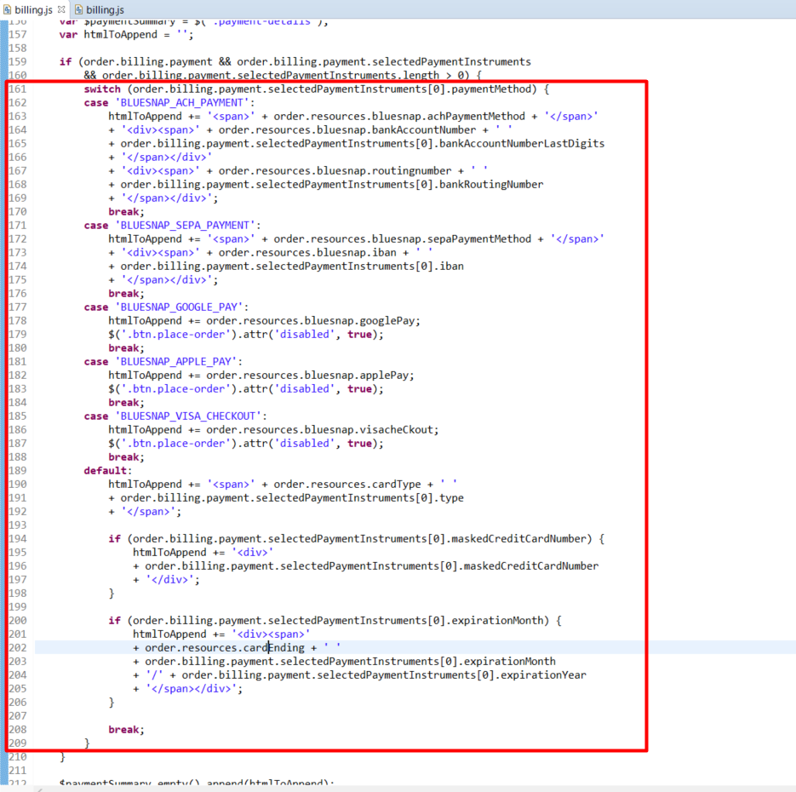

1. **int_bluesnap_sfra/cartridge/client/default/checkout/checkout .js**

Replace lines 217-242 with following

|  |
| --- |
| var cvvCode = null;  var cvvElement = null;  switch ($('.payment-information').data('payment-method-id')) {  // if payment method is credit card  case 'CREDIT_CARD':  if (!($('.payment-information').data('is-new-payment'))) {  cvvCode = $('.saved-payment-instrument.' +  'selected-payment .saved-payment-security-code').val();  if (cvvCode === '') {  cvvElement = $('.saved-payment-instrument.' +  'selected-payment ' +  '.form-control');  cvvElement.addClass('is-invalid');  scrollAnimate(cvvElement);  defer.reject();  return defer;  }  var $savedPaymentInstrument = $('.saved-payment-instrument' +  '.selected-payment'  );  paymentForm += '&storedPaymentUUID=' +  $savedPaymentInstrument.data('uuid');  paymentForm += '&securityCode=' + cvvCode;  }  break;  // if payment method is Vaulted Shopper credit card  case 'BLUESNAP_CREDIT_DEBIT':  if (!($('.payment-information').data('is-new-payment'))) {  cvvCode = $('.saved-vaultedshoppercard-instrument.' +  'selected-payment .saved-vaultedshoppercard-security-code').val();  if (cvvCode === '') {  cvvElement = $('.saved-vaultedshoppercard-instrument.' +  'selected-payment ' +  '.form-control');  cvvElement.addClass('is-invalid');  scrollAnimate(cvvElement);  defer.reject();  return defer;  }  paymentForm += '&securityCode=' + cvvCode;  }  break;  // if payment method is Vaulted Shopper LatAm credit card  case 'BLUESNAP_LATAM':  if (!($('.payment-information').data('is-new-payment'))) {  cvvCode = $('.saved-vaultedshopperlatamcard-instrument.' +  'selected-payment .saved-vaultedshopperlatamcard-security-code').val();  if (cvvCode === '') {  cvvElement = $('.saved-vaultedshopperlatamcard-instrument.' +  'selected-payment ' +  '.saved-vaultedshopperlatamcard-security-code');  cvvElement.addClass('is-invalid');  scrollAnimate(cvvElement);  defer.reject();  return defer;  }  paymentForm += '&securityCode=' + cvvCode;  }  break;  default:  break;  } |

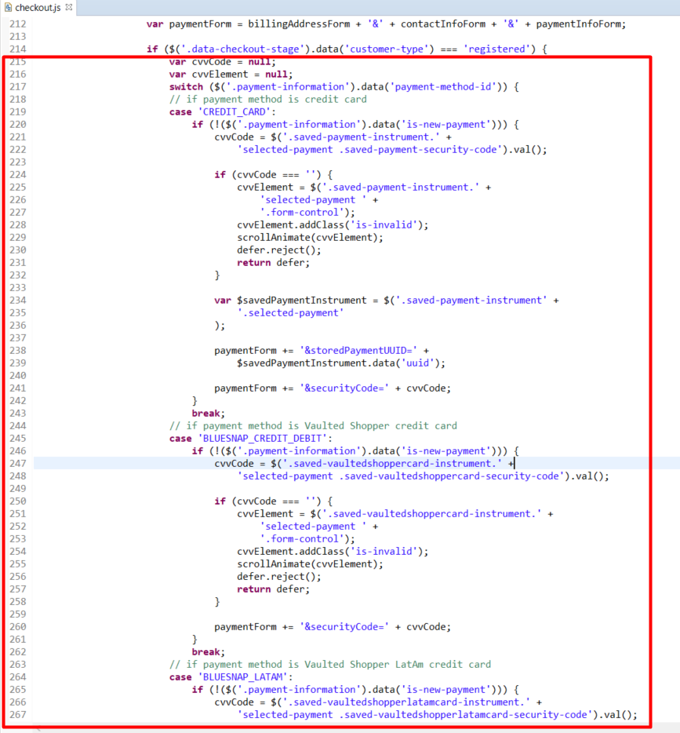

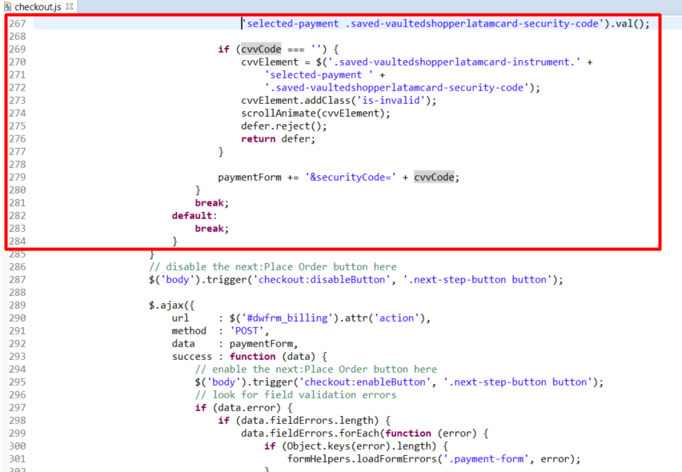

Paste the following lines into the 351 line

|  |
| --- |
| // Load payment button  var paymentMethod = $('.payment-information').data('payment-method-id');  if (paymentMethod == 'BLUESNAP_GOOGLE_PAY'  || paymentMethod == 'BLUESNAP_APPLE_PAY'  || paymentMethod == 'BLUESNAP_VISA_CHECKOUT') {  // $('body').trigger('checkout:disableButton', '.next-step-button button');  $.ajax({  url : $('#bluesnap-payment-buttons').data('url'),  method : 'POST',  data : { payment: paymentMethod },  success : function (data) {  $('#bluesnap-payment-buttons').empty().append(data);  },  error: function () {  }  });  } else {  $('#bluesnap-payment-buttons').empty();  } |

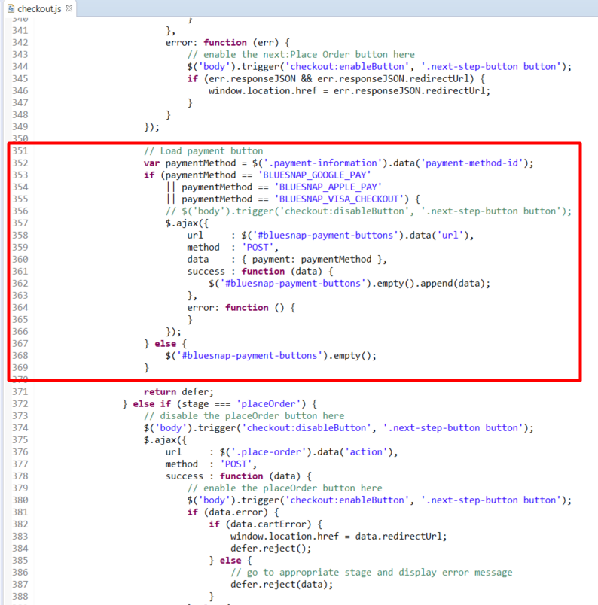

# Operations, Maintenance

## Data Storage

*Intentionally left blank.*

## Availability

*Intentionally left blank.*

## Support

*Intentionally left blank.*

# User Guide

## Roles, Responsibilities

*Intentionally left blank.*

## Business Manager

*Configuration options described above in 3.1.*

## Storefront Functionality

The BlueSnap cartridge adds payment methods to the storefront, and gives opportunity to place order via these pament methods. All theese pament methods are working through the BlueSnap — All-in-One Payment Platform. Also it allows customer to store credit cards on Bluesnap side and pay with one click.

# Known Issues

*Intentionally left blank.*

# Release History

|  |  |  |
| --- | --- | --- |
| **Version** | **Date** | **Changes** |
| 19.1 | August 2019 |  |